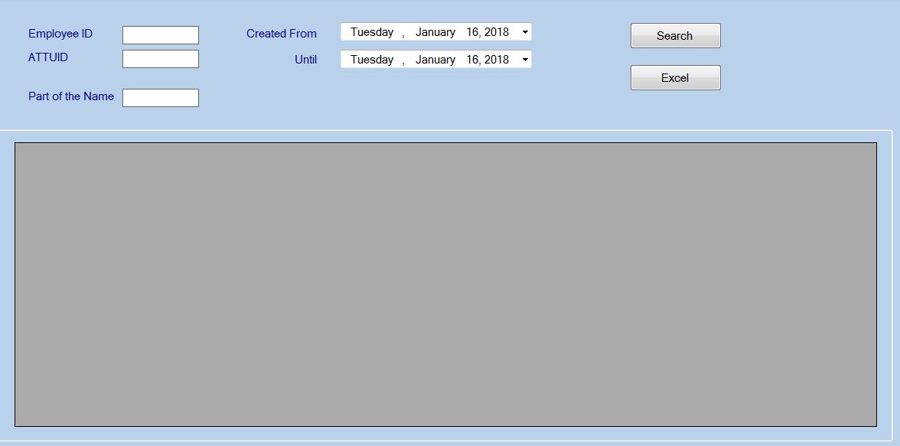

Grid inside group panel

Form Load

DataGrid.AutoSizeColumnsMode = System.Windows.Forms.DataGridViewAutoSizeColumnsMode.Fill;

DataGrid.Dock = System.Windows.Forms.DockStyle.Fill;

Anchor Group Panel

Anchor = Top, Bottom, Left, Right